Replace this with your contribution’s title

Corresponding Author^{a*}, Second Author^{b}, … and Last Author^{b,c}

- replace this with the first address
- replace this with the second address
- replace this with the third address

* replace with the email of « corresponding author »'

Replace all of this text by your abstract. The abstract can include one figure but should not exceed one page (A4). When you have completed your abstract, you should convert it to pdf and upload it to the conference website:
https://mecaqcolloq2019.sciencesconf.org/.
Language: Please write the title and abstract in English. We also require all slides to be in English[1].
[1] A.N. Author, and U.R. Another, Impact of the JMC method on physical processes, Phys. Rev. Z 111, 2222 (2018)
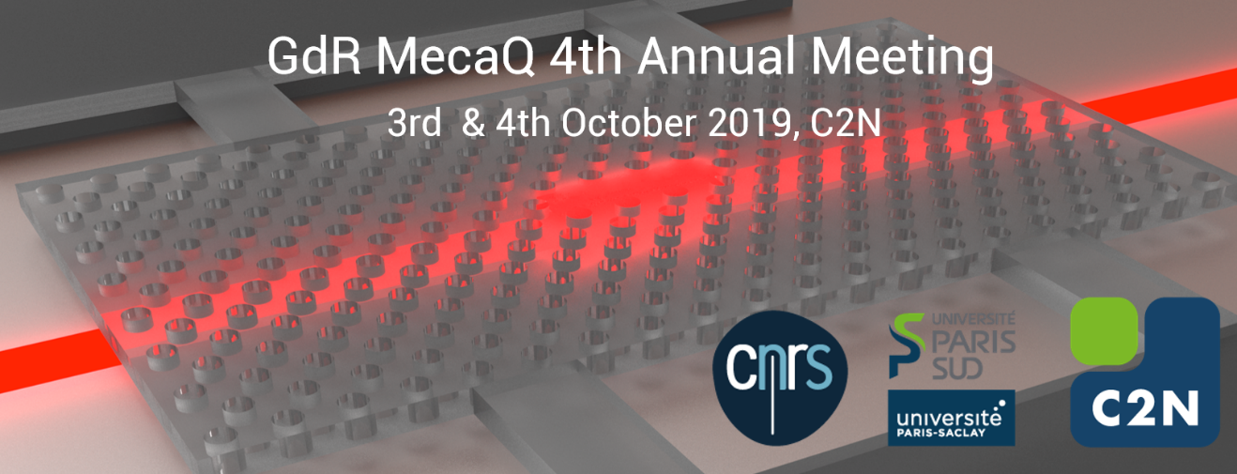

Figure 1 : Please make the image file as small as possible, while keeping reasonable resolution on screen (max 0.1MB).

